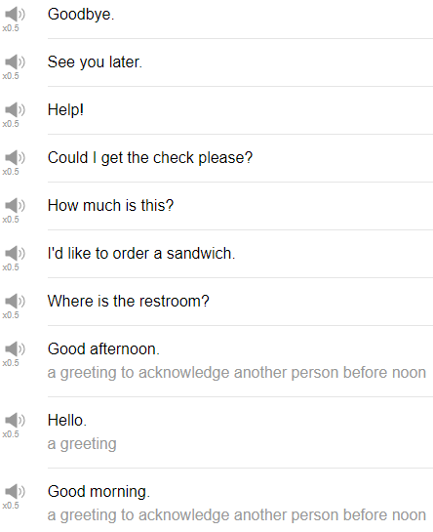

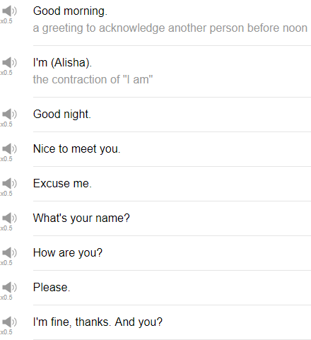

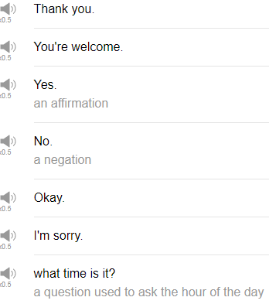

|  |
| --- |
| Hi everybody, my name is Alisha and today we are going to be talking about the top 25 English phrases. So let’s get started! |
| 1. The first phrase is “hello”. |
| Hello of course is used as a greeting. |
| You can greet your friends, you can greet your co-workers, |
| your family with this phrase just by saying hello. |
| Hey, hi, what’s up, hello, what’s up, yo. |
| Pretty much any time of the day you can use hello. |
| Hello. |
| 2. The next phrase is “good morning”. |
| Good morning is used as a greeting in the morning. |
| You can kind of feel when morning ends for you. |
| Good morning is nice and polite or even just morning with your close friends and close co-workers. |
| 3. The next phrase is “goodnight”. |
| Goodnight is fine. We don’t use this to greet other people. |
| We use it when we are saying goodbye to other people at night |
| or family members particularly mothers and fathers to say goodnight to their children before they put them to bed. |
| You can say it to your friend in a text message or in an email if you’ve been talking for a while, goodnight. |
| 4. So the next word to talk about is “goodbye”. |
| Use it when you say goodbye to your friends, when you leave your friends, |
| goodbye, bye of course, take care, have a nice day. |
| Peace out, that’s another way to say goodbye. |
| 5. Okay the next phrase is, “I am (plus your name)”. |
| Of course, this is a way to introduce yourself. |
| You can use I am – in my case Alisha. I am Alisha, to introduce yourself in any situation. |
| New friend, I am Alisha. |
| 6. Okay the next phrase is “what’s your name?” |
| And what’s your name is used to ask someone else what their name is. |
| So what is your name sounds a bit – try to use what’s your name. |
| If you forget someone’s name, you can say sorry what’s your name or sorry what’s your name again. |
| 7. Next phrase is “nice to meet you”. |
| Nice to meet you. Anytime you meet someone new, nice to meet you is fine, |
| good to meet you is a little more casual, |
| great to meet you sounds very excited, |
| pleasure to meet you sounds like maybe a formal situation or a business context. |
| 8. Okay the next phrase is “how are you?” |
| How are you is just a friendly way to check in with the other person. |
| You can use it with friends, your family, your coworkers, maybe even your boss to a certain degree. |
| How are you, how are you doing? |
| 9. The next phrase is “I am fine, thanks. And you?” |
| If you saw English in Three Minutes, we talked a lot about this phrase. |
| Instead of “I am fine, thank you. And you?” say “I am good, thanks, how are you?” |
| Just shorten it and make it a little bit more natural. |
| How are you? Good. |
| How are you? Great. |
| How are you? Not so good. |
| How are you, okay, and so on. |
| So when someone says how are you, offer I usually say I am good. |
| This week I blah, blah, blah give some information about what you’ve been up to, |
| maybe a hobby, something that you did recently, an event, something interesting you saw, whatever. |
| People want to make that connection with you and it’s a good chance for you to continue speaking. |
| 10. The next word is “please”. |
| Please is a polite phrase used when you want something from someone else. |
| You can use this as a response when someone offers you something like at a restaurant for example, |
| would you like more water? Would you like something to drink? Oh, please. |
| 11. The next phrase is “thank you”. |
| Thank you is used to express your appreciation. |
| You can use thank you with everybody. |
| 12. The next phrase is “you are welcome”. |
| You are welcome. When someone says thank you, you can say you are welcome, no biggie. |
| I use no biggie as in no biggie is short for no big problem. |
| 13. The next word is “yes”. |
| Yes, of course. Yes means it is any of this positive expression. |
| Someone asks you a question and the answer is a positive answer. |
| You say yes, yep, aha, yeah, we, no next time guessing a no, yep. |
| 14. The next word is “no”. |
| No is a negative response to something when you have to give a negative answer. |
| So as you can probably guess, the long form of no is negative. |
| I like to use nope, it’s very, very casual. |
| Not going to happen. My parents would use that with me. |
| To soften that a little bit, if you want to show a negative response to something. |
| Like let’s go for dinner tonight, what do you want to do? like, do you want to go out, not really, no I don’t think so, to soften it. |
| 15. The next word is “okay”. |
| Okay. This word comes from copyeditors okay when they had to check a manuscript. |
| They had to label the manuscript, all clear ac but because they were copyeditors and they have very, very sick sense of humor, they thought they would mark it okay for all clear to make a joke because o and k do not start all and clear but it caught on among everybody in the world. |
| Anyway okay is used to agree with somebody else. |
| Well it can be used actually to express a positive or kind of a slight negative I feel. |
| Transitioning in your conversation you can say okay, now we are going to talk about blah, blah, blah. |
| 16. Okay the next phrase is “excuse me”. |
| Excuse me, it’s used to get someone’s attention in English when you don’t know the other person. |
| For example, in a store or a supermarket, maybe a stranger on the street you need to ask directions, you can use excuse me. |
| You can use excuse me in the supermarket. |
| Excuse me can you tell me where the hot sauce is. |
| If you have done something rude in public, you can use excuse me. |
| I personally do not do rude things in public ever. |
| 17. “I am sorry” is the next word we are going to talk about. |
| I am sorry is used to apologize when you have made a mistake or someone you know has made a mistake and you are connected to it or you just feel bad, you can use I am sorry. |
| You made a mistake at work, I am sorry. |
| You forgot to feed your cat, I am sorry. Sorry about that. |
| You bumped someone next to you, sorry. |
| 18. “What time is it?” is the next phrase. |
| When you need to check what time it is: What time is it? |
| When you ask someone else what time it is. Maybe you say this to yourself too. |
| Check your watch, check your phone, check a clock, pretty straightforward phrase. |
| There aren’t really any short versions. So that’s an easy one. |
| 19. “Where is the (plus a location)?” |
| So you can use this for a building or a store. |
| We are not going to use this where is the for a place, a city name or a state name or a country name. |
| To do that, you would need to remove the but where is the bank, where is the post office. |
| You can use this to ask directions, to ask for help in your house or at work. |
| Where is the copy machine? Where is the file I need? |
| Where is the blah, blah, blah. |
| And where is the bathroom is perhaps a very important question to know. |
| 20. The next one is “may I use the restroom?” |
| May I use the restroom is a polite and soft expression that you can use if you need to use the toilet, |
| you need to use the washroom and when you are at someone’s house for the very first time, |
| when you are in a place that is new to you, you can ask may I use the restroom, and more casually, can I go to the bathroom? |
| To be very polite, you can say may I go to the bathroom? |
| 21. The next phrase is “I would like (to order something)”. |
| You can use this at a restaurant probably or in any situation where you need to place an order. |
| I’d like a pizza. |
| I would like a beer. |
| 22. “Can I get the check please?” |
| This will be used at a restaurant when you finished your meal and it’s time to go, can I get the check please. |
| In a very, very casual situation, you can just say “check please”, that’s fine. |
| 23. The next phrase is “see you soon”. |
| See you soon is used with friends and family members perhaps when you expect to see them again soon after saying goodbye to them. |
| This is used at the end of the conversation. |
| You are going in separate directions, you say, see you soon. |
| See ya is also good or just see you. |
| To make it a little more formal, you can say I will see you again soon, and make a full sentence out of it that way. |
| 24. The next phrase is “see you later” |
| See you later is very similar to see you soon but the point with see you later is that you are probably going to meet that person again later on in that same day. |
| 25. The last phrase is “really”. |
| Really is a very useful word because you can use it to show you are interested in a conversation with upward intonation, |
| really, really tell me more or to show that you are not so interested in the conversation with download intonation, really. |
| So there are many other words that you can use similar to really in this way like seriously or oh, oh and so on. |
| So it’s a really good practice for your intonation. |
| So those are 25 very common words and phrases in English. |
| If you like this video, if you like this topic, please subscribe. |
| I am sure there will be a button here somewhere or button here, wherever but please be sure to subscribe to our channel because we are going to be doing more videos like this and we already have more videos like this. |
| So please be sure to check them out. |
| Thanks very much for watching and let’s see you again soon. Bye! |
| Really? oh interesting, uh-huh, okay I see, great, fantastic, unbelievable! |
| Hmm… gratitude, subjects. |
| What do we have for dinner today? Pizza, affirmative. |